**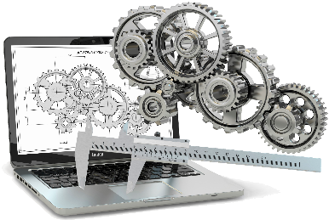*****Registration Sheet***

|  |  |  |  |
| --- | --- | --- | --- |
| ***Name:*** | …………………………………………… | ***Last name:*** | …………………………………………… |
| ***Quality:*** | …………………………………………… | ***Grade:*** | …………………………………………… |
| ***Affiliation:*** | …………………………………………… | ***Specialty:*** | …………………………………………… |
| ***Phone:*** | …………………………………………… | ***E-mail:*** | …………………………………………… |

***Theme:***

|  |  |  |  |
| --- | --- | --- | --- |
|  | *Topic 1:* | *1. Contact Mechanics & Mechanism*  *3. Machining & CNC Machines* | *2. Elasticity*  *4. Mechanical & Machine Design* |
|  | ***Topic 2:*** | ***1. Fluid Dynamics***  ***3. Internal Combustion Engine & Turbomachinery*** | ***2. Heat Transfer***  ***4. Renewable Energy*** |
|  | ***Topic 3:*** | ***1. Industrial Maintenance***  ***3. Tribology*** | ***2. Systems Reliability***  ***4. Vibration & Structures Dynamics*** |
|  | ***Topic 4:*** | ***1. Composite Materials***  ***3. Manufacturing Processes*** | ***2. Fatigue & Damage***  ***4. Strength of Materials*** |

*(Double click to activate or deactivate the box)*

|  |  |
| --- | --- |
| ***Article title:*** | …………………………………………………………………………………………………………………  ………………………………………………………………………………………………………………… |

|  |  |
| --- | --- |
| ***Co-auteurs:*** | …………………………………………………………………………………………………………………  ………………………………………………………………………………………………………………… |

*(Semicolon between co-authors)*

***Wishes to participate in the NCoME’25 by a communication***

|  |  |
| --- | --- |
|  | *Oral* |
|  | ***Poster*** |

*(Double click to activate or deactivate the box)*

***Date: ……/……/……***